User Acceptance Testing (UAT) Template
Date: 03 October 2026
Team ID: SWTID-2026-4310
Project Name: Implement Client Script & UI Policy (Incident)
Maximum Marks: —

Project Overview:
Project Name: Implement Client Script & UI Policy (Incident)
Project Description: Configure and test a UI Policy and Client Scripts on the ServiceNow Incident table, including Urgency field behaviour, form validation, and list editing.
Project Version: 1.0
Testing Period: to

Testing Scope:
- UI Policy on Incident table
- UI Policy Action for Urgency
- onChange Client Script
- onSubmit Client Script (save validation)
- onCellEdit Client Script
- Mandatory-field enforcement, reverse conditions, list-edit blocking, and form-based updates

Testing Environment:
URL/Location: ServiceNow Incident application / instance used by the project
Credentials: Use authorized project credentials only; do not record passwords in this document.

Test Cases:

Test Case ID | Test Scenario | Test Steps | Expected Result | Actual Result | Pass/Fail
TC-001 | UI Policy – Urgency | - Open Incident form  - Trigger policy condition  - Check Urgency | Urgency field follows configured policy action | To be recorded | To be recorded
TC-002 | onChange validation | - Change target field  - Observe form behaviour | Configured change occurs immediately | To be recorded | To be recorded
TC-003 | onSubmit validation | - Enter invalid/missing data  - Click Save | Save is blocked when validation fails | To be recorded | To be recorded
TC-004 | onCellEdit blocking | - Open Incident list  - Edit configured cell | Configured list edit is allowed/blocked as specified | To be recorded | To be recorded
TC-005 | Reverse condition | - Change condition from true to false  - Recheck field state | Policy reverses according to configuration | To be recorded | To be recorded
TC-006 | Form-based update | - Edit Incident form  - Save valid values | Record updates successfully | To be recorded | To be recorded

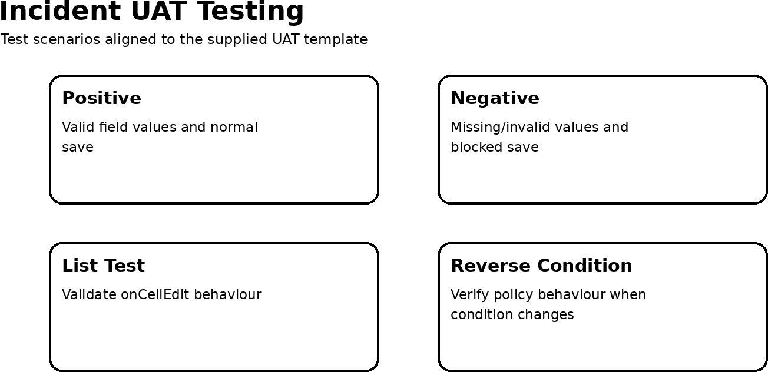

Bug Tracking:

Bug ID | Bug Description | Steps to reproduce | Severity | Status | Additional feedback
BG-001 | To be recorded if a project defect is found | Record actual reproduction steps | Low/Medium/H igh | Open/In Progress/Closed | Tester feedback

Sign-off:
Tester Name: Date: Signature:
Notes: All positive and negative scenarios should be executed. Bug tracking should include severity, status and reproduction steps. Sign-off should be obtained before deployment.

